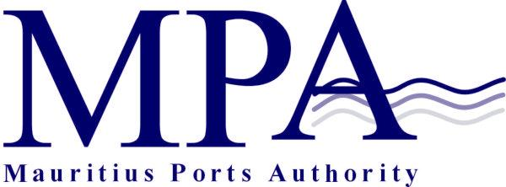
INVITATION FOR EXPRESSION OF INTEREST
ESTABLISHING A DRYDOCK/ SHIP BUILDING FACILITY AT PORT LOUIS HARBOUR
Contract MPA 554/2022

The Mauritius Ports Authority (MPA), established under the Ports Act 1998, is the landlord port authority with regulatory and controlling powers. The Authority holds a land domain of about 330 hectares at Port Louis Harbour.

The MPA is pleased to invite Expression of Interest from Prospective Applicants interested in establishing an international drydock/ship building facility at Port Louis Harbour. Interested Applicants, specialized in the field and willing to participate in this exercise may contact the office of:

The Manager, Administrative Services
Mauritius Ports Authority
H. Ramnarain Building
Mer Rouge, Port Louis
Republic of Mauritius
Tel: + 230 206 5400
Fax: +230 240 0856
Email: info@mauport.com

A complete set of the Invitation for Expression of Interest document will be submitted to eligible applicants via email.

Documents to be submitted
The Invitation for Expression of Interest Document comprises the necessary Applications Forms and lists the necessary documents/information to be submitted with the Expression of Interest.

Clarifications and Queries
All clarifications sought by prospective firms in respect of the Expression of Interest shall be addressed, at least 21 days, before the deadline for submission of the Expression of Interest, in writing to:

The Ag. Director General
Mauritius Ports Authority
H. Ramnarain Building
Mer Rouge
Port Louis
Mauritius
Fax No. (230) 240 0856
Email: info@mauport.com

Submission of Expression of Interest

The Expression of Interest in a sealed envelope, clearly marked “Contract MPA 554/2022 - Expression of Interest Establishing a Drydock/ Ship Building Facility at Port Louis Harbour” should be addressed to the Ag. Director General, Mauritius Ports Authority, H. Ramnarain Building, Mer Rouge, Port Louis, Republic of Mauritius.

The EOI should be sent by courier or deposited in the bid box located at the Chief Officer’s Office, Mauritius Ports Authority, 1st Floor, H. Ramnarain Building, Mer Rouge, Port Louis, Republic of Mauritius not later than Tuesday 30 August 2022 at 14.00 hrs (Mauritian time).

Any expression of Interest received after the closing date and time will not be accepted.

Reservation
The MPA reserves the right to accept or reject any interest expressed or annul the EOI without incurring any liability whatsoever.

Mauritius Ports Authority
H. Ramnarain Building
Mer Rouge, Port Louis
Republic of Mauritius

19 July 2022

