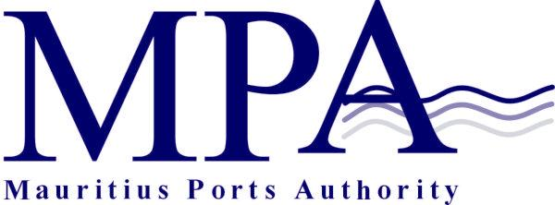
PROCUREMENT NOTICE

Invitation for Pre-qualification
(Authorised under Section 14(2) of the Public Procurement Act 2006)

Open International Invitation for Prequalification
Construction of a Fishing Port and Breakwater Structures at Fort William
Contract MPA 449/2019; CPB/75/2019

The Mauritius Ports Authority (MPA) intends to pre-qualify contractors for Contract MPA 449/2019 - Construction of a Fishing Port and Breakwater Structures at Fort William- CPB/75/2019. It is expected that invitations for bid will be made around mid-2020.

Interested eligible bidders may inspect the bidding documents at the office of:
The Director Legal and Administrative Services
Mauritius Ports Authority
H. Ramnarain Building
Mer Rouge
Port Louis
Republic of Mauritius
Tel: + 230 206 5400
Fax: +230 240 0856
Email: info @ mauport.com

Purchase of Pre-Qualification document
For Local Applicants
A complete set of pre-qualification documents may be purchased by interested local bidders on the submission of a written application to the above and upon payment (during week days) of a non-refundable fee of Mauritian Rupees two thousand only (MUR 2,000) by bank cheque drawn in the name of the Mauritius Ports Authority or by cash payable at the MPA Cash office located at 2nd Floor, H. Ramnarain Building, Mer Rouge, Port Louis, Republic of Mauritius.

For Overseas Applicants
Overseas applicants willing to participate in this exercise may purchase the Prequalification document by electronic payment equivalent to USD 65 or Euro 50 net of all bank charges to our bank as detailed below:-

Beneficiary: Mauritius Ports Authority
Bank: State Bank of Mauritius Ltd
Bank Address: 1, Queen Elizabeth II Street, Port Louis, Mauritius

Account Type: US Dollar
Account No. 61026000000401
IBAN No MU 84 STCB 1170 0260 0000 0401 000USD
Swift Code: STCB MUMU
Account Type: Euro
Account No.: 61026200001798
IBAN No.: MU 13 STCB 1170 0262 0000 1798 0000 EUR
Swift Code: STCB MUMU

An additional fee of Mauritian Rupees one thousand only (MUR 1,000.00) or US Dollars Thirty-five only (US$ 35.00) or Euro Twenty –five only (Euro 25) shall be charged to Applicants who wish to have the request for prequalification documents air freighted/couriered to them. However, the MPA would not be held liable for delays/non-receipt of the air-freighted/couriered documents due to default of the courier service.

Submission of Applications
One original and 2 copies of the applications (in hard copies only) must be submitted in accordance with the Instruction to Bidders in sealed envelopes clearly marked “CPB Reference: CPB/75/2019- Construction of a Fishing Port and Breakwater Structures at Fort William which shall be addressed to the Chief Executive, Central Procurement Board, 1st Floor, Social Security Office, Julius Nyerere Avenue, Rose Hill, Republic of Mauritius.

Deadline for the submission of applications
Applications for prequalification should be either deposited in the Bid box located in the Central Procurement Board, 1st Floor, Social Security Office, Julius Nyerere Avenue, Rose Hill, Republic of Mauritius or submitted by registered post/courier so as to reach the Central Procurement Board on or before Thursday 25 February 2020 up to 13.30 hrs. (local time) at latest.

Applications will be opened in the Conference Room of the Central Procurement Board on the same day at 14.00 hrs (local time) in the presence of bidders or their representatives who choose to attend.
Applications received after the specified closing date and time will not be considered.

The MPA reserves the right to
(a) accept or reject any bid; and
(b) to annul the bidding process and reject all bids at any time prior to the award of the contract as per provision of Section 39 (1) of the Public Procurement Act 2006.

Mauritius Ports Authority
H. Ramnarain Building
Mer Rouge
Port Louis
Republic of Mauritius
Tel: +230 2065400
Fax: +230 2400856
Email: info@mauport.com

12 December 2019

