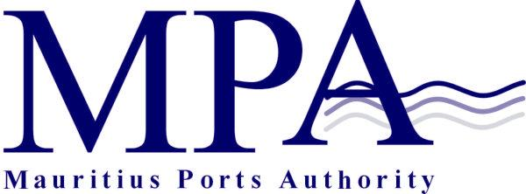
PROCUREMENT NOTICE
OPEN NATIONAL BIDDING
(Authorised under Section 17 of the Public Procurement Act 2006)
DESIGN AND CONSTRUCTION OF AN OPEN STEEL SHED AT THE MAURITIUS CONTAINER TERMINAL, MER ROUGE- Contract: MPA 443/2019

The Mauritius Ports Authority (MPA) is hereby invites sealed bids from local bidders for the Design and Construction of an Open Steel Shed at The Mauritius Container Terminal, Mer Rouge as more fully described in the bidding document.

The Scope of works include inter-alia:

The contractor shall be responsible for the design of the open steel shed including the foundations and all infrastructure (drainage, electrical, etc..). in this respect, the contractor’s team should comprise a multidisciplinary team including experienced Civil/Structural Engineer and Electrical Engineer for the design from either a consultancy firm or in-house.

The contractor will be required to submit to the MPA a Performance Security and Contractor’s All Risk Insurance following acceptance of the design prior to the start of works.

Qualification requirements
- The Contractor must hold a valid registration with CIDB as follows:
Class of work: Building Construction Works and/ or Prefabricated building and industrial plant/ or Steel framed building and industrial plant. Grade: At least Grade H.
- Experience as prime contractor in the construction of a minimum of one work of a nature and complexity equivalent to the Works over the past five years.
- Other qualifying criteria mentioned in the bid document.

Interested eligible bidders may inspect the bidding documents at the office of The Director Legal and Administrative Services
Mauritius Ports Authority
H. Ramnarain Building
Mer Rouge
Port Louis
Tel: 206 5400
Fax: 240 0856
Email: info @ mauport.com

Purchase of Bidding documents
A complete set of bidding documents may be purchased by interested bidders on submission of a written application to the above and upon payment of a non-refundable fee of Rupees One thousand only (Rs 1000) by bank cheque drawn in the name of the Mauritius Ports Authority or by cash payable at the MPA Cash Office located at the 2nd Floor, H. Ramnarain Building, Mer Rouge, Port Louis.

Submission of bids
One original and 2 copies of the bid (in hard copies only) must be submitted in accordance with the Instruction to Bidders in sealed envelopes clearly marked “Contract No 443/2019 - DESIGN AND CONSTRUCTION OF AN OPEN STEEL SHED AT THE MAURITIUS CONTAINER TERMINAL, MER ROUGE which shall be addressed to the Director General, Mauritius Ports Authority, H. Ramnarain Building, Port Louis.

Deadline for the submission of bids
Bids should be either deposited in the bid box located in the Chief Officer’s Office, Mauritius Ports Authority, 1st Floor, H. Ramnarain Building, Mer Rouge, Port Louis or submitted by registered post or courier so as to reach the Mauritius Ports Authority on or before Tuesday 10 September 2019 up to 14.00 hrs. at latest.

Bids will be opened in the Conference Room of the Mauritius Ports Authority on the same day at 14.15 hrs. in the presence of bidders or their representatives who choose to attend.

Bids received after the specified closing date and time will not be considered.

Pre- Bid Meeting
A pre-bid site visit has been scheduled for Friday 16 August 2019 at 10.00 hrs. The meeting place is the Conference Room of the Mauritius Ports Authority at Ground Floor, H. Ramnarain Building, Mer Rouge, Port Louis.

The MPA reserves the right to
- accept or reject any bid; and
- to annul the bidding process and reject all bids at any time prior to the award of the contract as per provision of Section 39 (1) of the Public Procurement Act 2006.

Mauritius Ports Authority
H. Ramnarain Building
Mer Rouge
Port Louis
Tel: 2065400
Fax: 2400856
Email: info@mauport.com

09 August 2019

