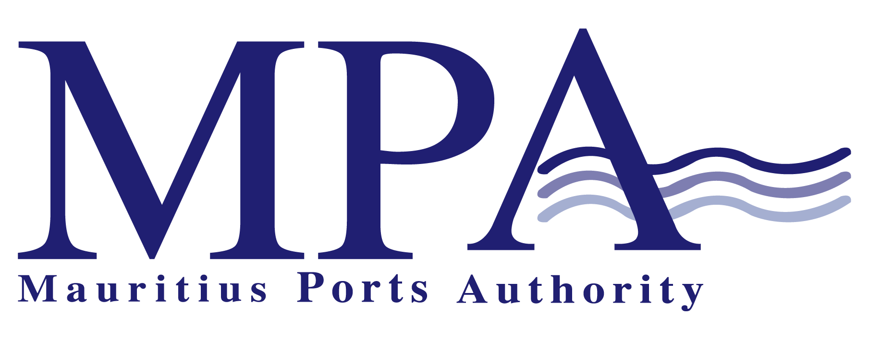

INVITATION FOR
EXPRESSION OF INTEREST
FOR
“THE SETTING UP OF A MARINA FACILITY TOGETHER WITH ASSOCIATED INFRASTRUCTURE DEVELOPMENT AT CAUDAN”

Contract: MPA 433/2019

Mauritius Ports Authority
H. Ramnarain Building
Mer-Rouge
Port-Louis
Tel (230) 2065400
Fax (230) 2400856

E mail address: info@mauport.com

May 2019

EXPRESSION OF INTEREST
FOR
“THE SETTING UP OF A MARINA FACILITY TOGETHER WITH ASSOCIATED INFRASTRUCTURE DEVELOPMENT AT CAUDAN”

The Mauritius Ports Authority (MPA) is pleased to invite proposals from local and international firms for the Setting up of a Marina Facility together with Associated Infrastructure Development at Caudan.

1. Purpose

To thrive with the transformation of the Port-Louis Harbour into a preferred maritime gateway, the Mauritius Ports Authority (MPA) is investing massively in the infrastructural development of the Harbour.
With the vision of revitalising Port Louis as a port centre and to re-connect the city to the sea, one of the main actions identified by both the Port-Louis City Vision 2030 and the Port Masterplan 2016 study is the setting up of a marina facility together with associated infrastructure development at the Caudan basin.
Indeed, the setting up of the Marina Project at Caudan would facilitate and boost the attraction of the international, regional and local sailing/yachting community to converge towards Port-Louis as a sailing destination. This will generate a bigger traffic of visitors and tourists, thereby increasing the spending per visitor on the different offerings in Port Louis.
Accordingly, the Mauritius Ports Authority (MPA) is hereby soliciting an Expression of Interest from potential parties/promoters interested in setting up the marina facility at the Caudan basin.

2. Background Information
As per the recommendations of the Port Louis Masterplan 2016, the water plan in the Caudan Basin has been identified for development of a marina.
The Caudan basin is very shallow with approximately 3 m of water depth. The existing quay walls surrounding the basin are old and are susceptible to collapse if any attempt are made to deepen the sea bed close to the wall.
The basin is identified for the marina project due to its sheltered location and is used by fishing boats and catamarans as a safe haven during the passages of cyclones over Mauritius. During normal conditions, the basin is mostly used by leisure crafts but in an unstructured way.
The perimeter of the Caudan basin is bounded by stakeholders comprising of both MPA lessees and private land owners, as per the annex plan.
Extract from the Port Louis Masterplan 2016 is enclosed with respect to the level of local boating activities for potential users of the marina facility.

- Objective

In line with the recommended development of a Marina at the Caudan basin, the MPA intends to select a promoter who would conceptualise, design, construct and operate the marina together with its associated infrastructures and facilities.

- The proposed project
The project shall comprise the development of a marina facility which should include the following basic facilities but shall not be limited to:
- Berthing/docking system for the leisure boats and yachts.
- Utilities and facilities like electricity, water supply, toilets, lighting.
- Fuelling supply and storage
- Land side area access roads
- Marina management services
The plate below shows the location plan of the Caudan basin where the Marina facility is earmarked to be developed:

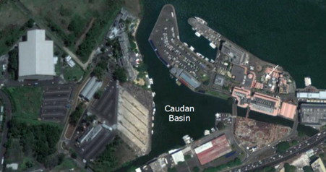

5. Levy Charge Payable
The MPA acknowledges the challenges of operating a marina facility as well as the commercial and financial opportunities for the potential operator.

The aim is to create a "Win-Win" for all the stakeholders. The levy charge payable shall be determined on the exact extent of water plan area which shall be used exclusively by the successful promoter and taking into consideration the promoter's business plan projections and the forecasted investment in the facility and infrastructure development.

- Request for Proposal: Detail List
The response to the Request for Proposal shall include the following information:
- Description of the concept plan for the marina facility infrastructures, services and operations;
- Provision for operational Schedule (days and hours the services will be per month);
- Include a general business plan for the marina operations and describe any plans for expansion of services, advertising, or other factors that will contribute to the long term economic growth of the Port-Louis harbour;
- Describe the number and type of jobs the business plan envisages creating;
- Include envisioned partner jobs or services and the local economic multiplier effects;
- Full contact details including the Name, addresses, telephone number and e-mail of the applicant;
- Complete resume of the applicant and all principal personnel directly involved with the management and operation of the facility or services;
- Evidence of experience of the applicant and key personnel in the management and operation of marina facilities and its services;
- Financial statement of the prospective lessee indicating sufficient resources available for successful promotion, management and operations of the facility.

- Evaluation Criteria
The critical criteria which will be considered for evaluation include inter-alia:

- Proposals will be evaluated on financial resources, general business plan, job creation and contribution to the economic development of the port
- Experience of team
- Short and long term financial impact to the Port of Port Louis
- Services offered and site optimisation
- Other factors deemed relevant by the Port

- Reservation of rights
The MPA reserves the right to modify the terms of this EOI at any time, waive any irregularities in the submittals. Reject any and or all proposals, negotiate with top-rated Respondent(s) and accept any proposal deemed to be in the best interest of the Port. This EOI should, in no way, be construed as a commitment from MPA to conclude any venture with any of the bidders.

- Right to Withdraw
Respondents may withdraw a proposal which has been submitted at any time up to the proposal closing date and time. In this respect, a written request signed by an authorized representative of the Respondent must be submitted to the MPA. Following the withdrawal of a previously submitted proposal, the Respondent may submit another proposal at any time up no later than the closing date and time for this EOI.

- Cost of Preparation of Proposal
MPA shall not be liable for any costs incurred in the proposal preparation, printing, interview, or negotiation process.

- Clarifications and Queries
All clarifications sought by the firms in respect of the Expression of Interest shall be addressed, at least fourteen days, before the deadline for submission of the Expression of Interest in writing to:

The Director General
Mauritius Ports Authority
H. Ramnarain Building
Mer Rouge
Port Louis
Mauritius
Fax No. (230) 240 0856
Email: info@mauport.com

- Submission of Expression of Interest
The Expression of Interest in a sealed envelope, clearly marked “Expression of Interest for the Setting Up of a Marina Facility Together with Associated Infrastructure Development at Caudan - Contract MPA 433/2019” should be addressed to the Director General, Mauritius Ports Authority, H. Ramnarain Building, Mer Rouge, Port Louis, Republic of Mauritius.

The EOI should be sent by courier or deposited in the bid box located at the Chief Officer’s Office, 1st Floor, H. Ramnarain Building, Mer Rouge, Port Louis, Mauritius not later than Tuesday 18 June 2019 at 14.00 hrs (local time).

Any expression of Interest received after the closing date will not be accepted.

Note:
- Foreign bidders are requested to consult the website of the Economic Development Board at http://www.edbmauritius.org to take cognizance of the requirements for foreign investment.
- Bidders may download the Expression of Interest free of charge at the following website: publicprocurement.govmu.org and www.mauport.com

Plan showing the Stakeholders at the perimeter of the Caudan Bassin

SN | Stakeholders | Main Activities
1 | Caudan Development Ltd | Waterfront activities
2 | IBL Entertainment Ltd | Commercial/office developments
3 | Innodis Ltd | Commercial/office developments
4 | United Docks Ltd | Residential/Commercial/office/freehold developments
5 | Tropical Paradise Ltd  (Le Suffren Hotel) | Hoteling activities

Extract from the Port Louis Masterplan 2016

